MTF survey in Bangladesh
The MTF survey in Bangladesh, undertaken by the government agency Power Cell, was based on a nationally representative sample (including rural and urban areas) of 4,500 households and was carried out during September–December 2017. Geographically, the survey covered all eight of the country’s divisions, the highest level of geographic administration. From each division one district was selected (the divisional district). One more district was randomly selected from the four largest divisions, making the number of total districts twelve. At the next stage, two or three upazillas (sub-districts) were selected from the districts, and then 375 enumeration areas (EAs) were sampled from the upazillas. Twelve households were then selected from each EAs, making the total sample of 4,500 households.
The indicator of interest, needed for sample size calculation, is the current grid-connectivity rate in the country, which is unknown. A 50% rate was assumed, which is the most conservative option possible as it gives the maximum sample size. A 5% margin of error was assumed, with the provision that reliable estimates by urban and rural areas are required. Finally, an allowance for a 10% non-response rate was considered. The sample selection was based on a multi-stage stratification strategy. In the first stage, City Corporations and two or three upazillas, including sadar upazillas (satellite upazillas for the district), from each of the twelve districts were selected. In the second stage, primary sampling units, which are EAs, were selected randomly. In the third stage, households from each selected EA were selected. MTF household survey sampling strategy aimed at keeping a 50:50 ratio between grid-electrified and non-grid households, and also a 50:50 ratio between urban and rural areas. While a 50:50 ratio was maintained for urban and rural household selection, this ratio could not be adhered to while selecting grid-connected and non-grid households because of the lack of adequate number of non-grid households in most EAs. Table 2 shows the distribution of sample households and figure 2 shows the GPS coordinates of the sampled households in a map of Bangladesh.
Since the distribution of grid and non-grid households in the sample differs from that in the population, any findings derived directly from the data are expected to be biased. To adjust such biases, sampling weight was used in the analysis so that the findings are representative of the rural and urban areas, and at the national level. Details of sample-size calculation are beyond the scope of this report, but suffice it to say that calculation of sample weight requires census data with rural-urban disaggregation, with an estimation of grid-connectivity status at the division level. Census data collected by Bangladesh Bureau of Statistics from 2011 was used to calculate the population projection for 2017 when the MTF survey was carried out. For those EAs selected in the first stage, the electrification status of households was obtained from the listing activity.

TABLE: Distribution of sampled households by grid access in the MTF survey, Bangladesh
District | Total number of EAs | Urban areas |  | Rural areas
District | Total number of EAs | Grid HHs | Non-grid HHs | Grid HHs | Non-grid HHs
Dhaka | 87 | 527 | 1 | 426 | 90
Chittagong | 55 | 323 | 1 | 251 | 85
Comilla | 39 | 240 | 0 | 166 | 62
Sylhet | 25 | 144 | 0 | 92 | 64
Mymensingh | 37 | 202 | 26 | 165 | 51
Rajshahi | 19 | 105 | 3 | 73 | 47
Bogra | 25 | 156 | 0 | 92 | 52
Rangpur | 21 | 120 | 0 | 67 | 45
Nilphamari | 13 | 84 | 0 | 48 | 24
Khulna | 17 | 96 | 0 | 62 | 46
Jashore | 20 | 119 | 1 | 48 | 72
Barishal | 17 | 107 | 1 | 51 | 45
Total | 375 | 2,223 | 33 | 1,561 | 683
Note: EA = enumeration area: HH = household.

FIGURE 2 * GPS coordinates of sampled households from MTF survey, Bangladesh
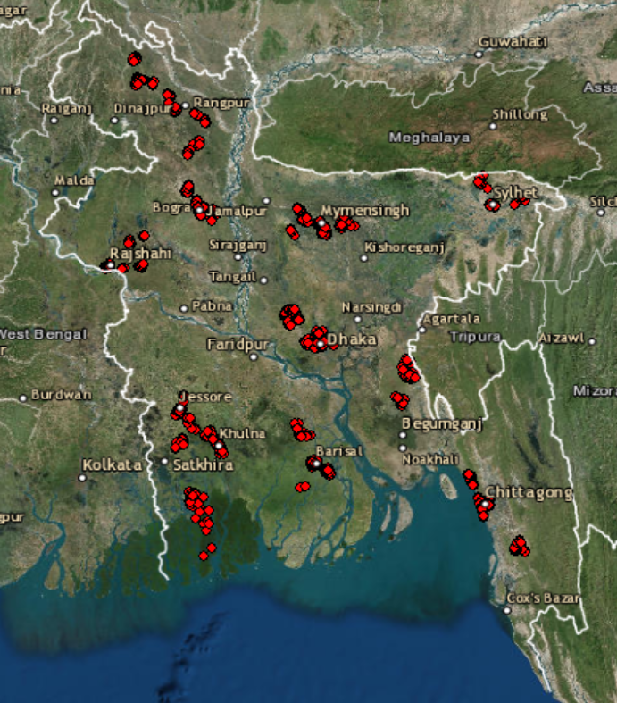
Source: MTF household survey 2017.

The survey was physically carried out by the consulting firm Micro Industries Development Assistance and Services (MIDAS).
Sampling weight is an adjustment factor applied to each observation of the data to adjust for differential selection probability of the households and make the findings representative of the underlying population.

